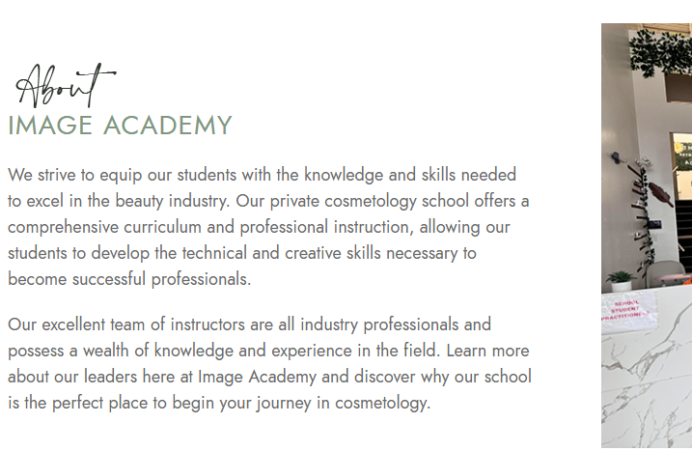
About Image Academy
At Image Academy, we strive to equip our students with knowledge and relevant skills required to succeed in the beauty industry. Being a private cosmetology school, we offer a comprehensive curriculum and proper directions to develop all necessary technical and creative skills to become leading professionals in the beauty field.
Our highly qualified staff is composed of highly experienced professional instructors knowledgeable in various aspects of the beauty industry. Learn more about our team and visit Image Academy to discover why our institution will be the perfect beginning of your professional path to becoming a qualified cosmetologist.

